9-1-23
Dear Parents,
The year is off and running and so are the plans for your child’s music concert. I am sending home this initial notice to allow you to plan your schedule accordingly. A reminder note will come home approximately two weeks in advance of the actual concert. Here are the dates:

3rd Grade = December 14, 2023 (Thursday)
2nd Grade = January 25, 2024 (Thursday)
4th Grade = February 22, 2024 (Thursday)
1st Grade = March 21, 2024 (Thursday)
Kindergarten = April 25, 2024 (Thursday)

All concerts will be held at the Clearview High School Auditorium at 7:00 p.m. with your child arriving at 6:30 p.m. for attendance check-in and warm-ups.
Sincerely,
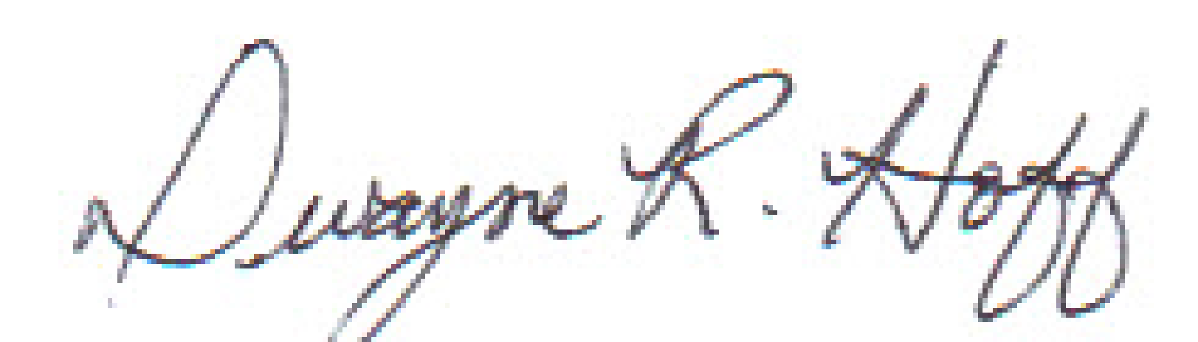
Dwayne R. Hoff
Vincent Elementary Music Teacher
Dwayne.hoff@clearviewschools.org

